**CS 2401 – Elementary Data Structures and Algorithms**

**Fall 2024**

**Lab 3**

**Due Date: XXXXXX**

**Objective:**

The goal of this assignment is to practice file reading, input processing, Linked Lists, and 2D Arrays.

**Background:**

You are traveler and you have extra money to acquire new items, (e.g. swords, amulets, staffs), You only have enough space for 4 more items on top of your own item. What will buy or sell?

**Assignment – Timeline:**

Milestone 1 – [XX] – [XX]

**Task 1 –** Main / InventoryLL

* You need to read the inventory file named “itemList.csv”, you will then put all the item information into a 2D Array
* You then will work on the InventoryLL.java class in which you will make the make a constructor when there is no node given and when a node is given
* You will need to the complete the methods addToInventory(), inInventory(), removeItem(), displayItems(), getFromInventory().
  + **addToInventory(Node item) –** This method is where you will add the items that you “purchased” into the linked list (your inventory)
  + **inInventory(String itemName) –** Checks if the item is in your inventory
  + **removeItem(String itemName) –** Removes the item from your inventory, regardless of their position
  + **displayItems(Node headNode)-** Will go through the linked list and display all items and their rarity, and HP in your inventory
  + **getFromInventory(Node currNode. String getItem)-** This method will search through the lined list and return the item we are looking for

**NOTE: You must add an item to your linked list before adding or removing items**

Milestone 2 – [XX] – [XX] Lab Submission

. **Task 1 –** Menu

* The menu is partially done with displaying what each option should do, e.g. viewing shop, Viewe inventory, Sell item, Buy item, View item stats, and Exit

* You will be provided with being able to view the shop, which will list all the items in the csv and their attributes if user selects 1

* When user selects 2 they will be able to view their inventory, which requires using one of the methods that you will find in InventoryLL

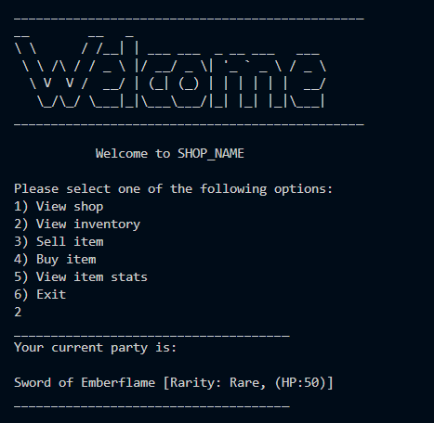

* Case 3 is where you will sell items that are in your inventory(linked list) where you will need at least one item in your linked list. After checking if you have at least one item, you will display your current inventory, where you then input what you want to ‘sell’, make sure to check that the item is actually in your inventory
* Case 4 is where you will add items to your inventory (linked list), your inventory MUST NOT exceed 5 items, you will then input what you want to add. When adding the item you must check that it is not already in your inventory, if it is not you must search through the shop (2D Array) and add it to your inventoryA screenshot of a computer program

  Description automatically generated

* Case 5 is checking a single item in your inventory and displaying all the attributes of the item
* 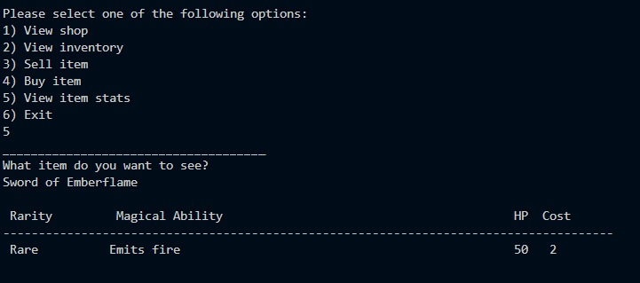
* Case 6 is where you will leave the shop

**Deliverables:** You are expected to submit one file in Blackboard (in your lab section). Please use PULSE to develop your solution, then either

(1) Press **Submit** in PULSE, OR

(2) download the .java file (from the **Folder**), rename it as shown below, and submit it in Blackboard. **NOTE: This will also be your class name in java**

Lab3_Lastname.java --- the java file of your program.

**Grading Criteria:**

* + [10 points] The program is indented correctly.
  + [10 points] The program is documented properly.
  + [10 points] The program uses correct variable types and meaningful variable names.
  + [20 points] Program compiles and runs.
  + [50 points] The program has correct logic and generates correct output.
* Late submission: [**-10**] points for every 24 hours after the deadline.

If you need any clarification, please ask your TA for further details.